**Contact Us**



**Living an Effective Lifestyle Inc.**

**2010 Winston Park Drive, Suite 200, Oakville,**

**ON L6H 5R7**

**We'd Love to hear from you**

Thank you for your interest in our services and products, we are waiting to hear from you. We promise to respond to your inquiries in a timely manner. Do get in touch now, you'll be glad you did!

**How to reach us**

Office: Suite 200, 2010 Winston Park Drive, Oakville. Ontario, **L6H 5R7**

☎Main Line:  +1 289 291 7781

☏ Direct Line:  +1 905 379 2427

✉ Email: info@livinganeffectivelifestyle.com

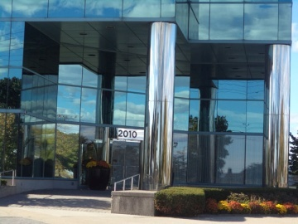

**Needed Updates:**

1. Please use the symbols (,☎,☏ & ✉) as you see fit.

2. Remember to use the **L6H 5R7** postal code

3. Remember to use the different telephones, Main: +1 289 291 7781 and Direct: +1 905 379 2427

4.